# Installing Python 3.x.x

* Start the installer
* Check the ‘**Add Python 3.x to PATH**’ checkbox
* Click the ‘Customize installation’ link

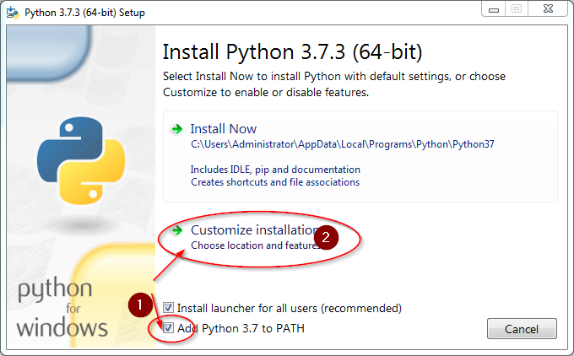

Ensure all checkboxes are selected and click **Next**:

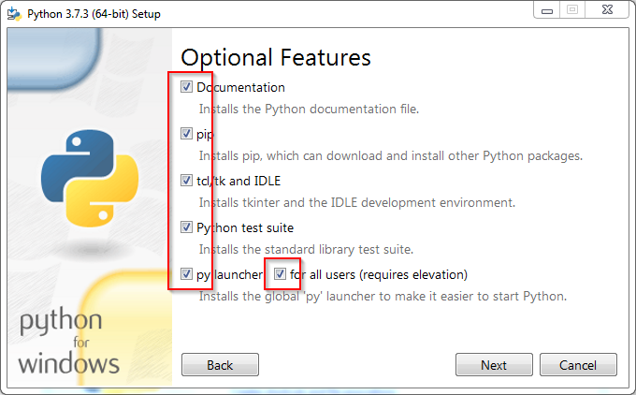

Select ‘**Install for all users**’ and ensure the location is **C:\Python3x**, and click **Install**:

